Brand profile -user user

email -user user

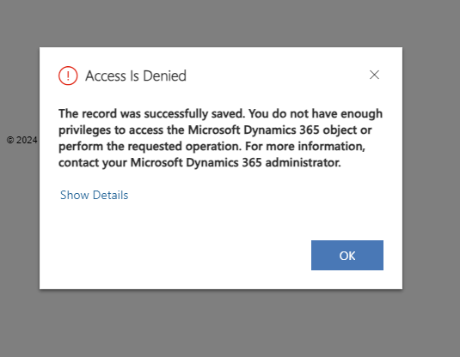

Brand -org

Email-user-working fine

While creating email based on email template getting error

So email template -append append to, user level- only he can use email templates that he created for creating emails other wise he will get error

Email template -append append to org level.